**AddressIQ API - Batch Address Standardization - Postman Testing Steps**

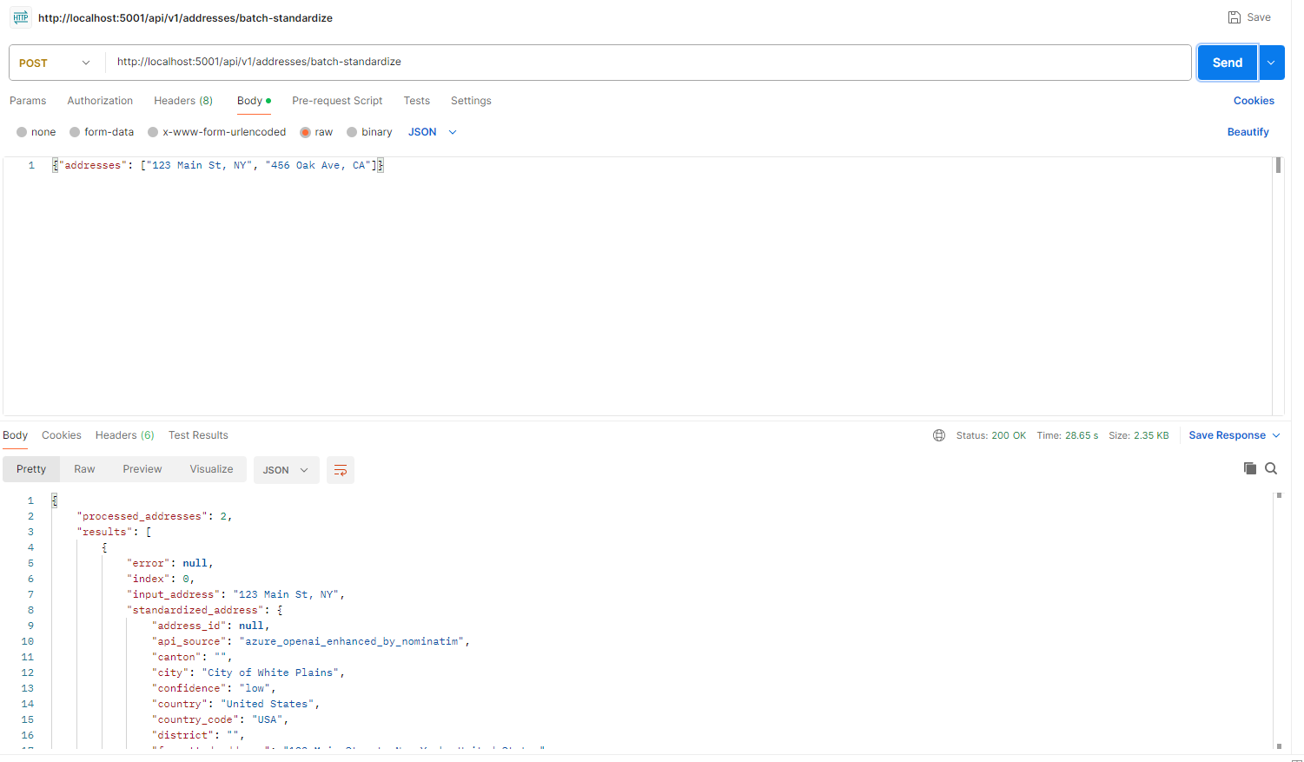

**STEP 1: Open Postman**

* Launch Postman application
* Create a new request

**STEP 2: Configure Request Method**

* Set Method to: POST
* ← In screenshot: Method dropdown set to "POST" **(USER FILLS THIS)**

**STEP 3: Enter API URL**

* Enter URL: http://localhost:5001/api/v1/addresses/batch-standardize
* ← In screenshot: URL bar with the API endpoint **(USER FILLS THIS)**

**STEP 4: Configure Request Headers**

* Click on "Headers" tab
* Add header: Content-Type = application/json
* Add header: X-API-Key = your-api-key-here (if API key is required)
* ← In screenshot: Headers tab with Content-Type and X-API-Key headers **(USER ADDS THIS)**

**STEP 5: Configure Request Body**

* Click on "Body" tab
* Select "raw" option
* Select "JSON" from dropdown
* ← In screenshot: Body tab with "raw" and "JSON" selected **(USER SELECTS THIS)**
* Enter the JSON payload:

{ "addresses": [ "123 Main Street, New York, NY 10001", "456 Oak Avenue, Los Angeles, CA 90210", "789 Pine Road, Chicago, IL 60601" ] }

← In screenshot: JSON payload in body area **(USER TYPES THIS)**

**STEP 6: Send Request**

* Click the blue "Send" button
* Wait for processing (typically 5-15 seconds for batch processing)
* ← In screenshot: Status "200 OK" and response data **(SHOWS SUCCESS)**

**STEP 7: Review Response**

* Check response contains batch processing results
* Verify each address has standardized components
* Note the success status for each address in the batch
* Review individual error messages for failed addresses
* ← In screenshot: Response body with batch results array **(PROCESSED RESULT)**

**SUCCESS INDICATORS:**

* Status: 200 OK (shown in screenshot)
* Response contains "success": true
* Response contains "total_addresses" and "processed_addresses" counts
* Each address result includes standardized components
* Latitude and longitude coordinates provided for successful addresses
* Confidence scores between 0.0 and 1.0 for each address
* Processing time typically 5-15 seconds depending on batch size

**TROUBLESHOOTING:**

* If you get "400 Bad Request" error → Check JSON format and ensure "addresses" is an array
* If you get "401 Unauthorized" error → Add X-API-Key header if API key is required
* If you get connection error → Make sure server is running on localhost:5001
* If you get "Maximum 1000 addresses per batch" error → Reduce batch size to 1000 or fewer addresses
* If some addresses fail processing → Check individual error messages in results array
* If processing is slow → Consider reducing batch size for faster response times

**That's it! Your batch of addresses will be standardized and returned with detailed components and coordinates for each successful address.**